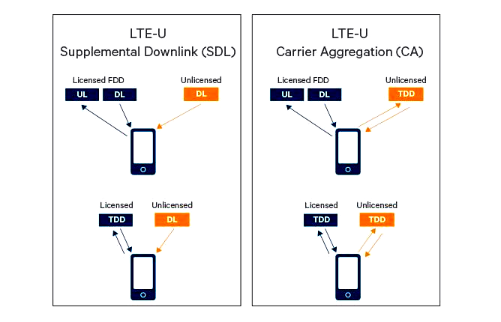

(a) Downlink only (a) Uplink and Downlink

